**Create a Use Case Diagram for the proposed system**. Include all the actors (or users) with one or more use cases for each actor. The use cases (ovals) should correspond to the daily business processes of the system you are proposing.

Things to consider: Who are all the actors/users of the system? What are the daily business processes of the system? Based on the ERD, who will be maintaining (adding, updating, or searching) each entity? Will the actors be solving any of the problems identified? What interfaces will they need?

Additional information on Use Case Diagrams:

<http://www.andrew.cmu.edu/course/90-754/umlucdfaq.html>

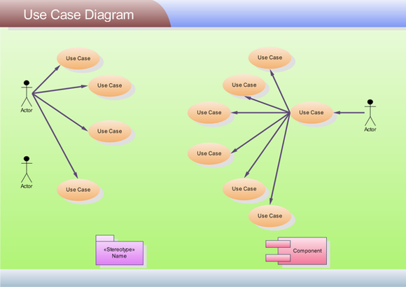

#### Scoring Guide

|  |  |
| --- | --- |
| Criteria | Ratings |
| Diagram has a title and uses correct grammar, punctuation, and spelling | 4 2 1 0 |
| Diagram includes all relevant actors that are labeled | 4 2 1 0 |
| Diagram includes all relevant use cases that are labeled | 4 2 1 0 |
| All job duties must be accounted for | 4 2 1 0 |
| Actors have appropriate use case that relates to the proposed system | 4 2 1 0 |
|  | **20** |